ANA-050 RICE Specification
M3 Implementation
Functional Specification
M3 AvaTax Integration

Document Properties
Author | Wade Langer
Creation Date | 04/21/2025
Last Updated | 4/28/2025
Document Reference | <Document Reference Number>
Version | 1

Approvals | Position
<Approver1>
<Approver2>

Document control

Change record
Date | Author | Version | Change Reference
04/21/2025 | Wade Langer | V1

Reviewers
Functional Review
Name | Position
 | Solution Architect

Technical Review
Name | Position
 | Senior Solution Architect

Table of Contents
1 Document control 2
1.1 Change record 2
1.2 Reviewers 2
2 Introduction 4
2.1 Purpose 4
2.2 Scope 4
2.3 Note on Data Conversion Components 4
2.4 Exclusions 4
2.5 User Characteristics 4
3 Requirements 5
3.1 Product Functions 5
3.1.1 User Stories 5
3.1.2 Use cases 5
3.2 Scenarios 6
3.3 Business Process Flows 6
3.4 Assumptions 11
3.5 Risks 12
3.6 Dependencies 12
3.7 Definitions, Acronyms and Abbreviations 12
3.8 Business Rules 13

Introduction

Purpose

This specification principally documents the following:
- Functional Requirements
- Non-Functional Requirements
- Technical Specification

The primary goal of this document is to consolidate all the necessary information required to integrate AvaTax with M3 for Sales Tax.

It specifically aims to provide a comprehensive mapping and the logic to populate Sales Tax values In M3, both for quoting and before invoicing. It is to be noted that M3 reporting will not facilitate Sales Tax filing, and that data will be populated from AvaTax.

Scope
The Sales Tax functionality will be performed via M3 Integration.

Note on Data Conversion Components
For the specification and design of project-specific data conversion components please refer to your project’s Data Migration Strategy.

Exclusions
. This Functional Specification document does not include the following functionalities:
- This functional specification only details the needed requirements to populate and update the defined fields in M3.
- AvaTax will not be utilized for taxes on purchases.

User Characteristics

User Role | Description
SALES | Users connected to this role will have access to create Cos.
GLMGR | Users connected to this role will have access to controller responsibilities. Controllers must oversee sales tax accounting in the general ledger and reporting for compliance.

Requirements
Task ID 1104

Product Functions

User Stories
Describe a product and its functionality from the viewpoint of the user, and can be tabulated as follows:

Task Reference | Work Reference | Description | As a(n) | I want to | So that | Acceptance Criteria
Reference to User Story in Tasks | ID of Work | Brief name or description | Type of user (as previously described) | Goal of the development | The reason for the development | Brief detail on how the story can be verified, basic criteria to determine if story has been fully implemented.
1104 | Avalara Site access | Avalara tax site information needed for configuration | SALES & GLMGR | Utilize AvaTax | Sales Tax is calculated based on delivery location | Sales tax design as specified by approved ANA has been developed and tested

Use cases

Component | Description
Primary Actor | Sales Person
Secondary Actor(s) | Controller
Trigger | Trigger 1: Order in M3 created in M3  Trigger 2: Order is invoiced in M3.
Pre-Conditions | Delivery location is a Sales Tax applicable GEO Code
Context of Use (i.e. event retrieving sales tax data. | Daily
Steps | - Sales user creates new order in M3.  - At time of invoicing, an AvaTax API call will be triggered by the invoicing charge based on order details.

Business Process Flows

The standard AvaTax integration sends M3 a Sales Tax result based on defined tax rules in AvaTax and provided sales order information. This includes information such as the line type, GEO code of delivery address and any flex fields.

This functional specification details how to capture the sales tax result.

PROCESS FLOW
  - AvaTax Configuration
    - AvaTax integration will be used as standard to return Sales Tax calculation to M3
  - M3 Configuration

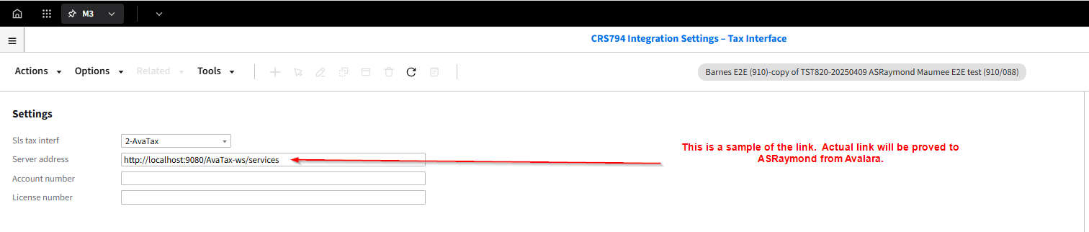

Assumptions
Ref | Work Reference | Assumption
 |  | Any use tax compliance and reporting should be done through Avalara.

Risks
Ref | Work Reference | Risk

Dependencies
Ref | Work Reference | Dependency

Definitions, Acronyms and Abbreviations
Term | Description
H5 Script | An HTML 5-based user interface allowing users to access work-related information and applications from the M3 business system. Scripts are used to personalize and enhance the functionality of standard M3 programs
ION | Infor Open Network middleware
CO | Customer Order
AvaTax | Tax Compliance Software

Business Rules

